**Exp. 17 Create a web app in the VM**

**Aim:**

To create a Simple Web Application using Java or Python and host it in any Public Cloud Service Provider (Azure/GCP/AWS) to demonstrate Platform as a Service (PaaS).

**Procedure:**

* Open the created VM using RPD file
* In the notepad, type the required HTML code
* Host it using XAMPP
* Run the web app in localhost/index.html

**Output:**

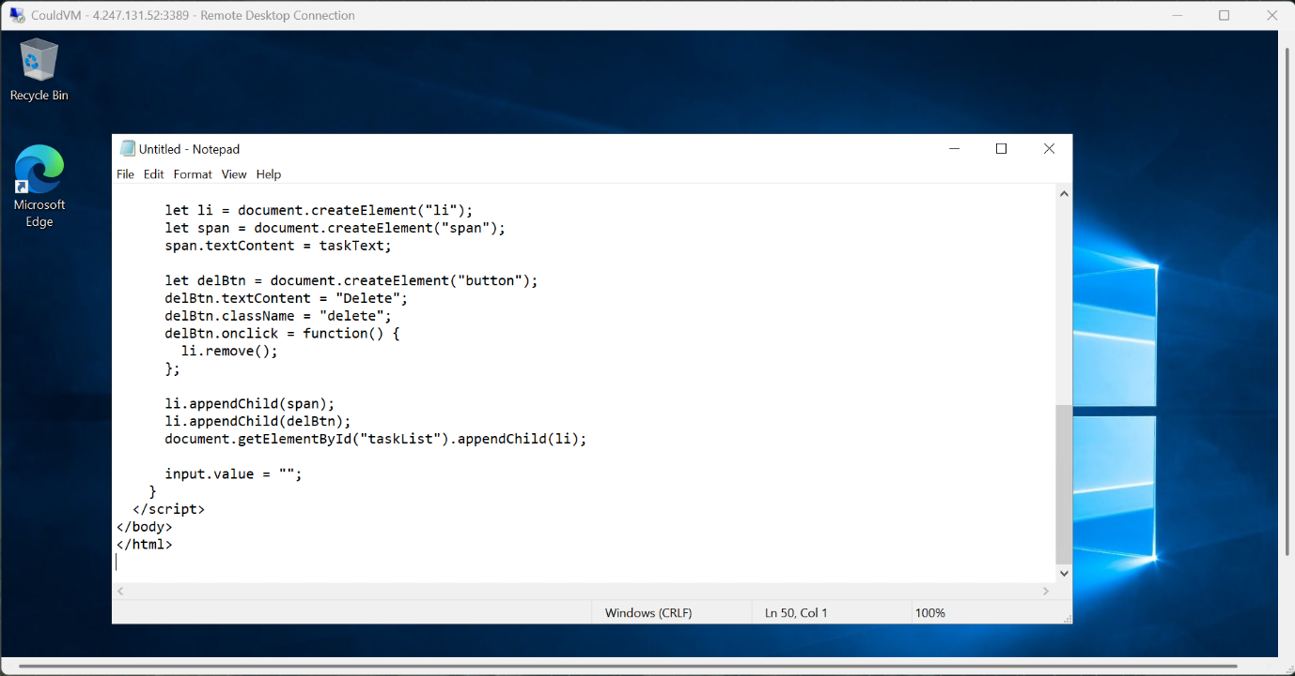

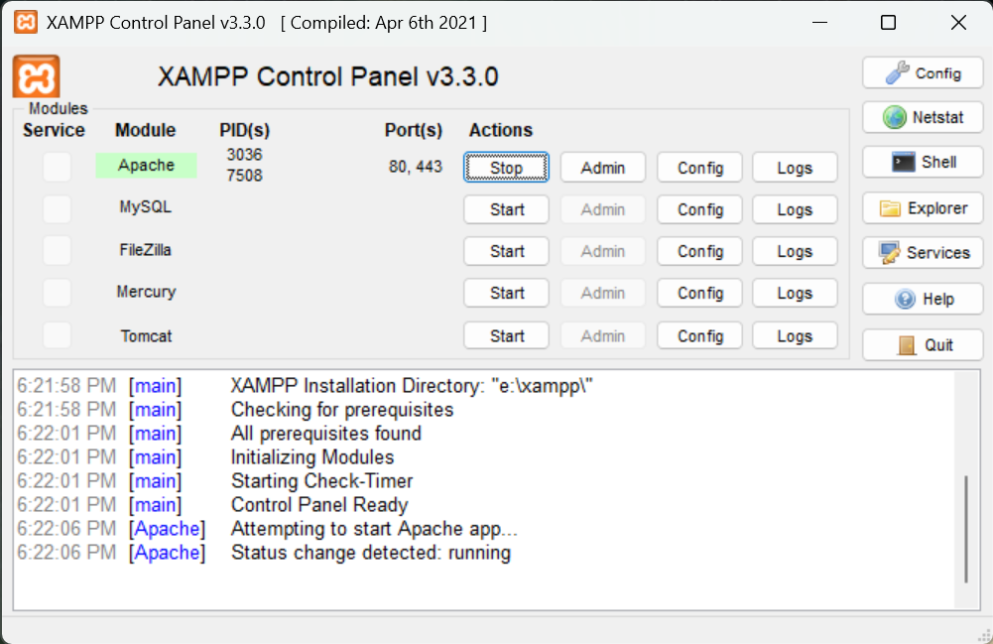

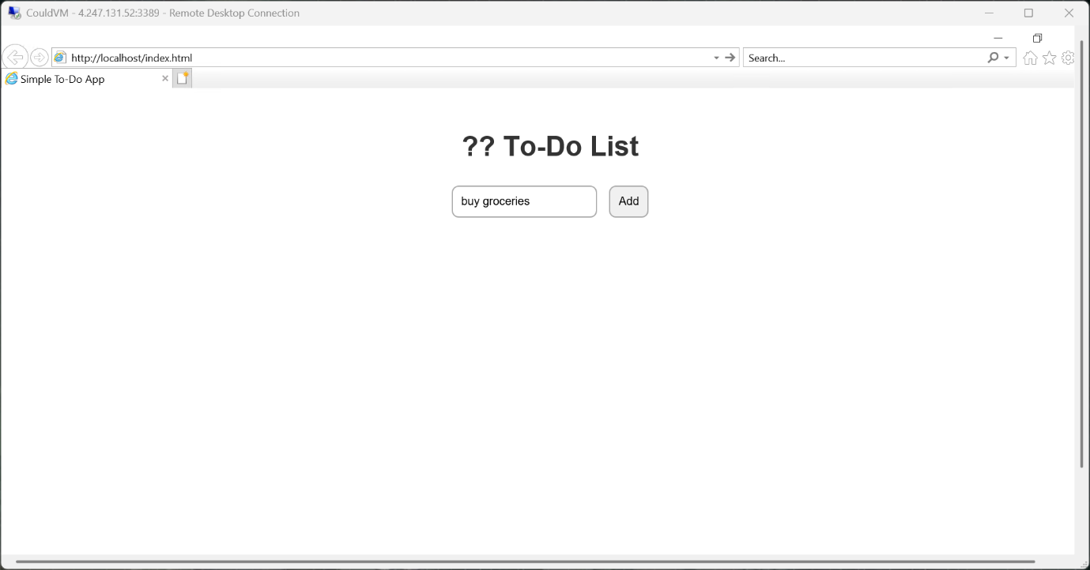

**Result:**

Thus the web app was hosted successfully